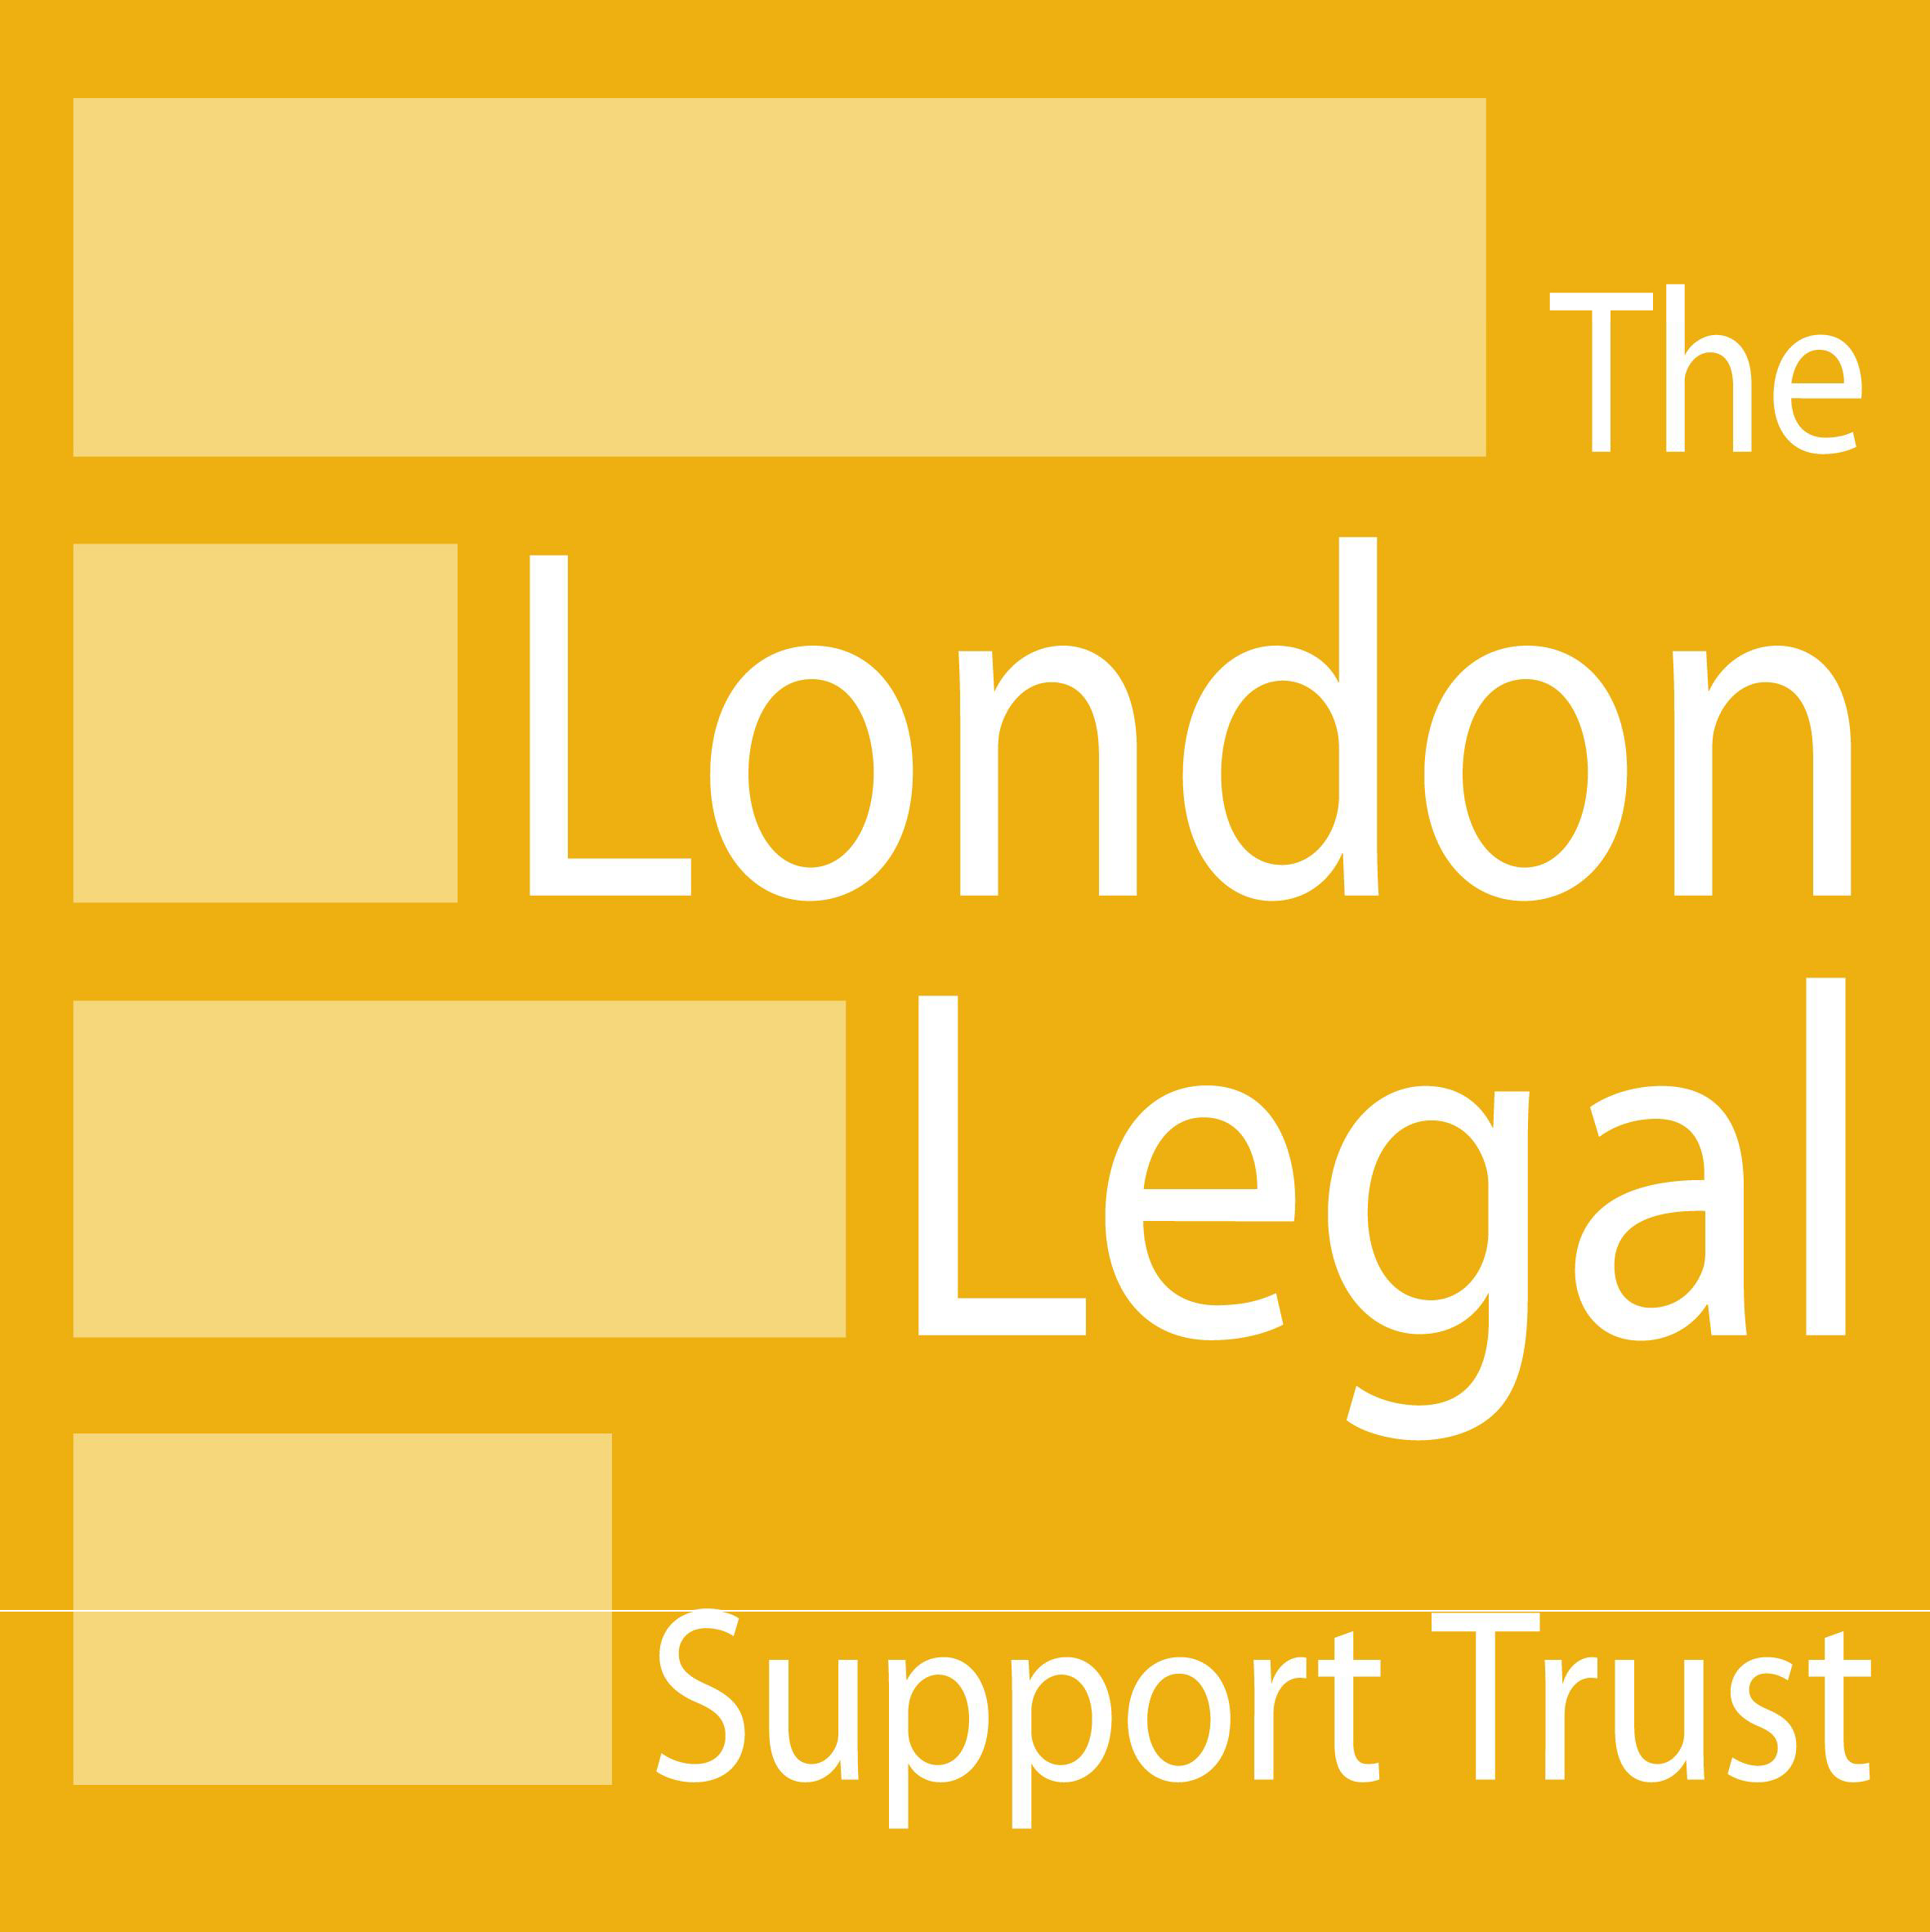London Legal Walk 2012
Will you be walking for justice?

Monday 21st May 2012

London South Bank University
& South London Law Society Team

Together with the South London Law Society, we are once again taking part in the London Legal Walk to raise money for a law centre in Zambia and the LSBU legal Advice Clinic.
The 10km sponsored walk starts at the Royal Courts of Justice, meanders through the London parks, finishes at the Law Society Hall and takes place on the evening of Monday May 21st. Hundreds of lawyers, Judges and students take part - it's the networking event of the year !
Please send your name to Andy Unger, Head of the Law Department, ungerad@lsbu.ac.uk, if you would like to be a walker - we want as many as possible - and please direct everyone you can to our donation page:
http://uk.virginmoneygiving.com/LSBULegalAdviceClinic
Last year, our first time, we raised over £3,000 but we want to raise much more this year.
The London Legal Walk is a 10km sponsored walk around some of London’s legal landmarks. With over 5,000 walkers, it is (probably!) the largest annual gathering of lawyers in the world. Walking in teams as their court, law firm or chambers, law college or in-house legal department, walkers raise hundreds of thousands of pounds for agencies who provide free legal advice to those in desperate need who cannot afford to pay.

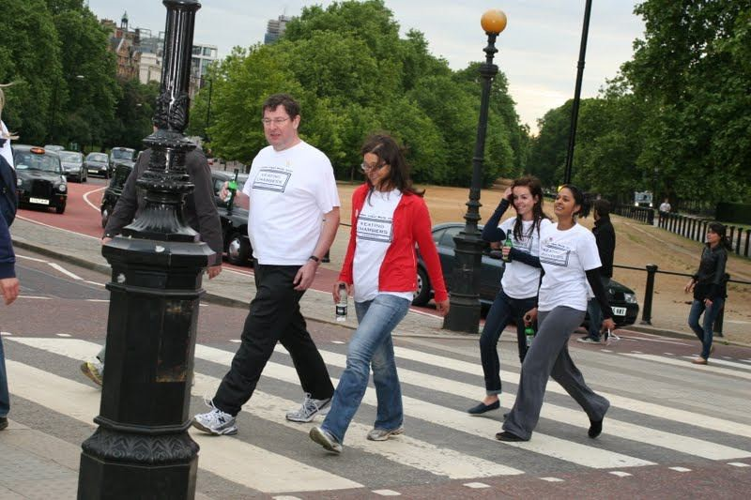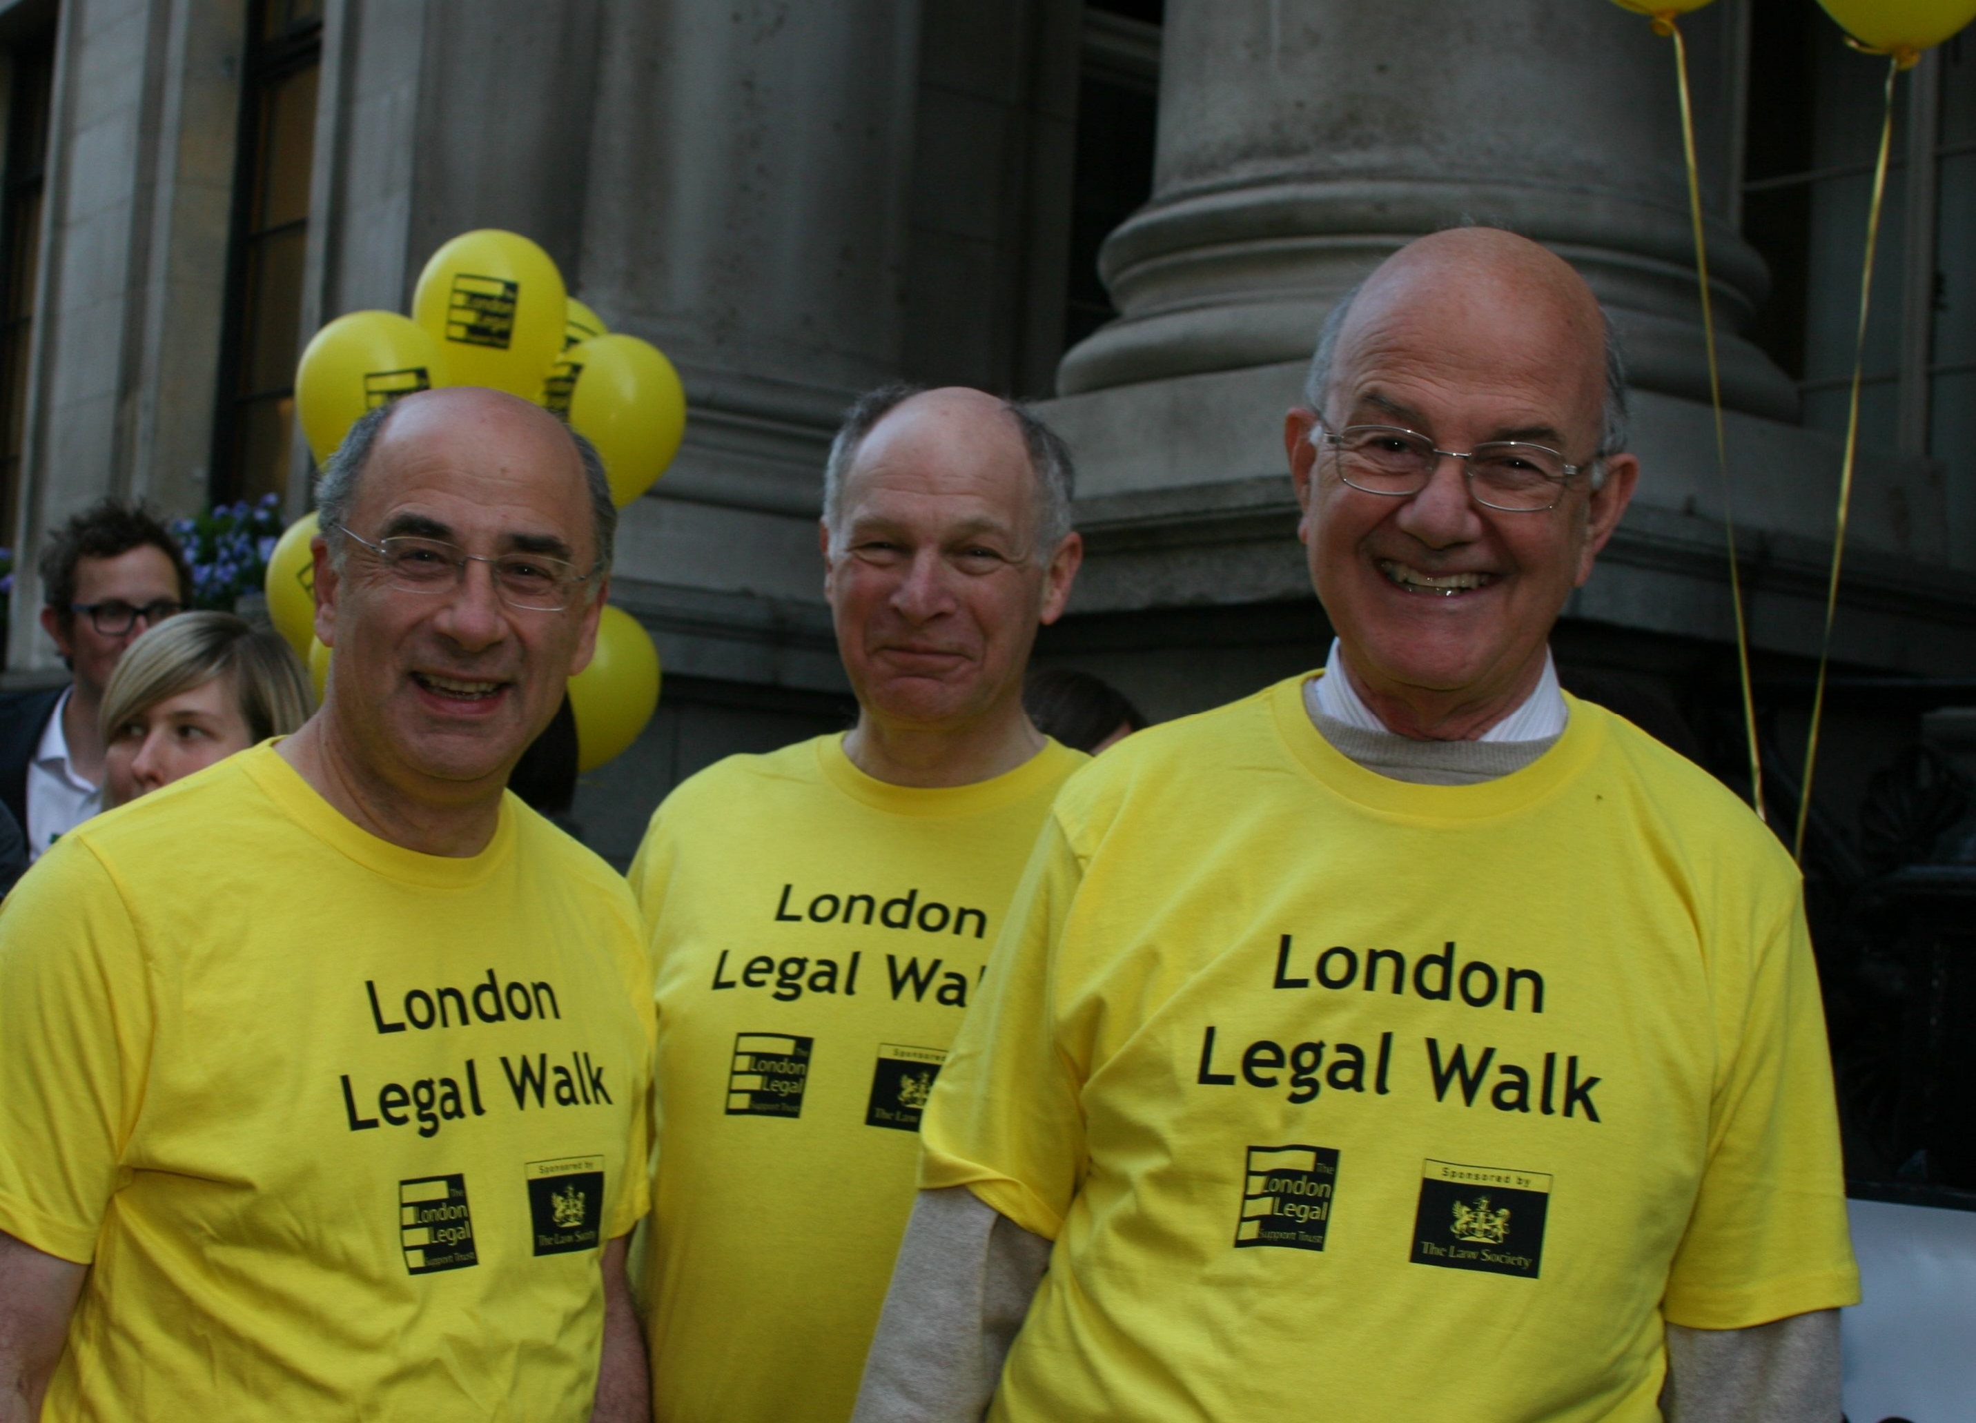

Walk leaders so far confirmed include:

Lord Judge—The Lord Chief Justice Lord Neuberger—The Master of the Rolls
Dominic Grieve QC MP—The Attorney General Keir Starmer QC—The Director of Public Prosecutions
The Presidents of the Law Society of England and Wales and CILEx and the Chairman of the Bar Council

